**220121788 - TENGEEVANDU KATJIUONGUA v1**

**220125295 - TRAY-VONN CLOETE v1**

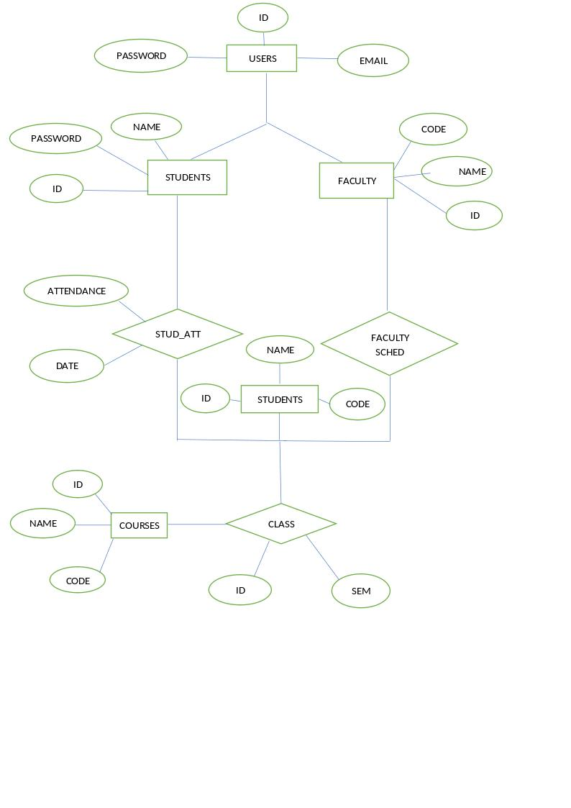

**220125295 - TRAY-VONN CLOETE v2**

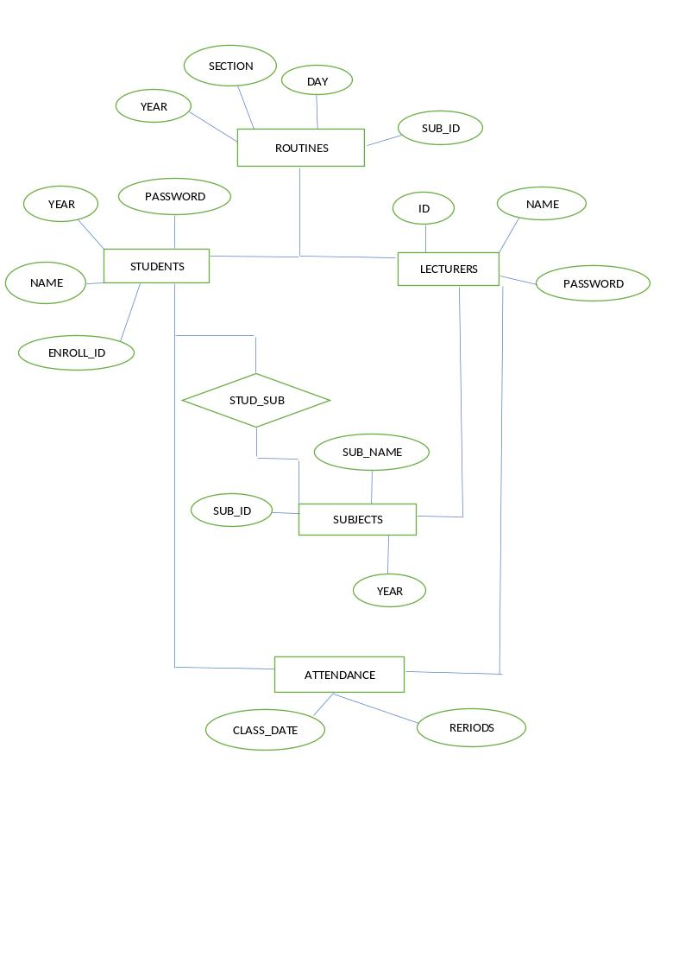

**217089445 - FESTUS NANGULA**

**220125627 - GIFT LISWANISO v1**

